Test Case: tc002_SPX_Dev5_Crear_Requisicion_Spot_Tipo_Cobro_Project
Step 1 - Enter username and password and click to button Enter: Credentials Entered
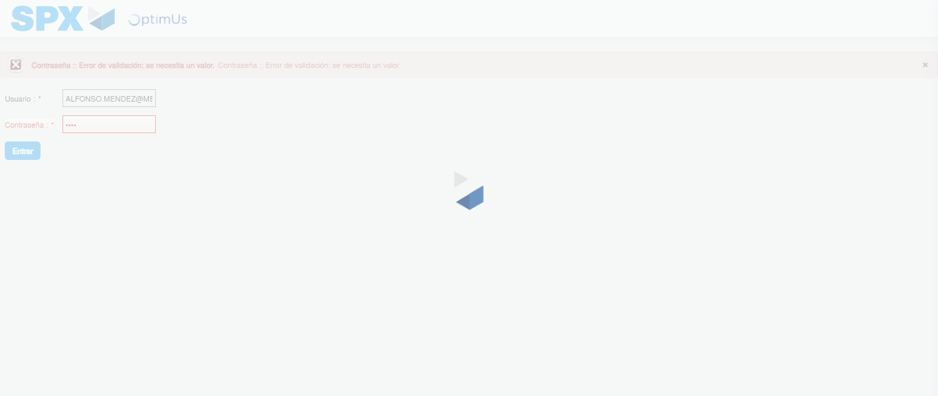Image file-name: QC_Testing-tc002_SPX_Dev5_Crear_Requisicion_Spot_Tipo_Cobro_Project-1784307564518

Step 2 - Select to UEN and Access to Spot Buy Requisitions : UEN Correctly selected and Correct access
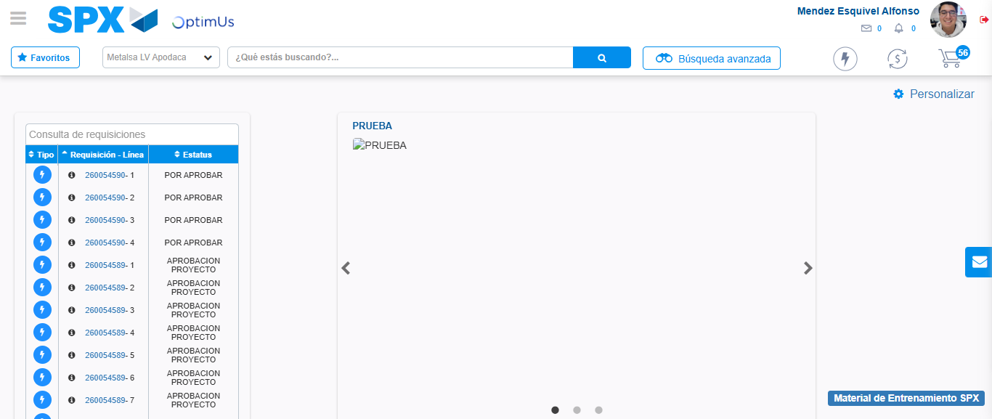Image file-name: QC_Testing-tc002_SPX_Dev5_Crear_Requisicion_Spot_Tipo_Cobro_Project-1784307635779

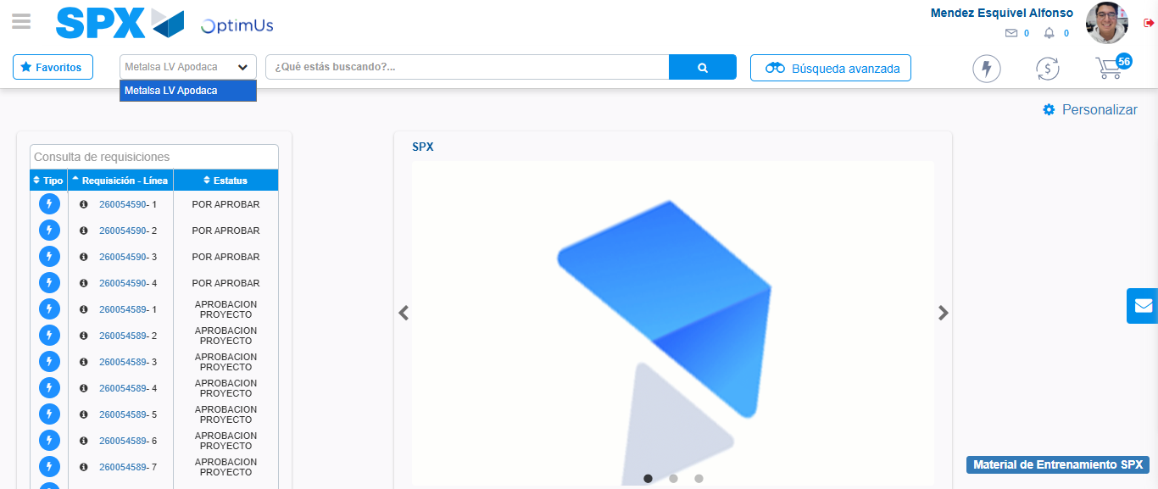Image file-name: QC_Testing-tc002_SPX_Dev5_Crear_Requisicion_Spot_Tipo_Cobro_Project-1784307638245

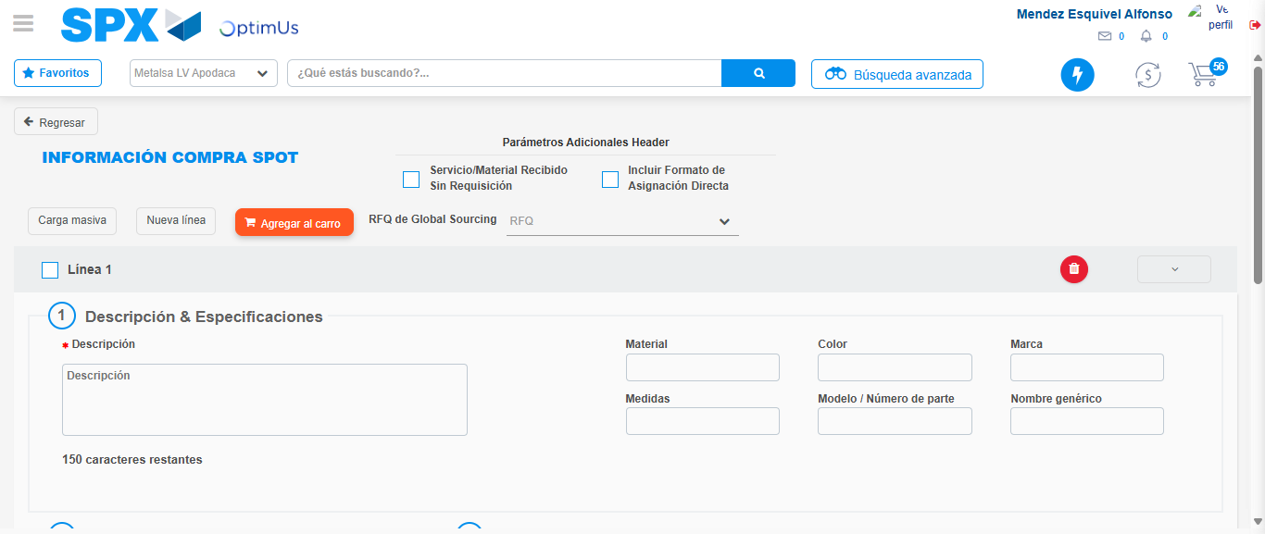Image file-name: QC_Testing-tc002_SPX_Dev5_Crear_Requisicion_Spot_Tipo_Cobro_Project-1784307667215

Step 3 - Data Capture Spot Buy Requisition: Data captured correctly
Image file-name: QC_Testing-tc002_SPX_Dev5_Crear_Requisicion_Spot_Tipo_Cobro_Project-1784307667479

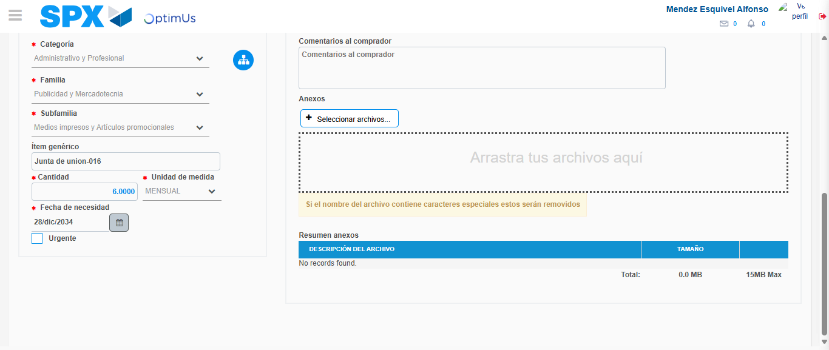Image file-name: QC_Testing-tc002_SPX_Dev5_Crear_Requisicion_Spot_Tipo_Cobro_Project-1784307679000

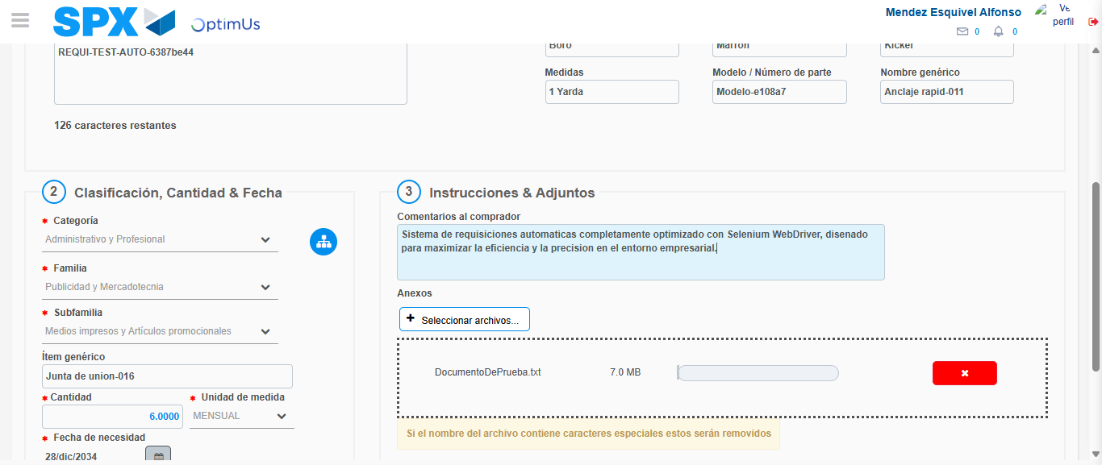Image file-name: QC_Testing-tc002_SPX_Dev5_Crear_Requisicion_Spot_Tipo_Cobro_Project-1784307679738

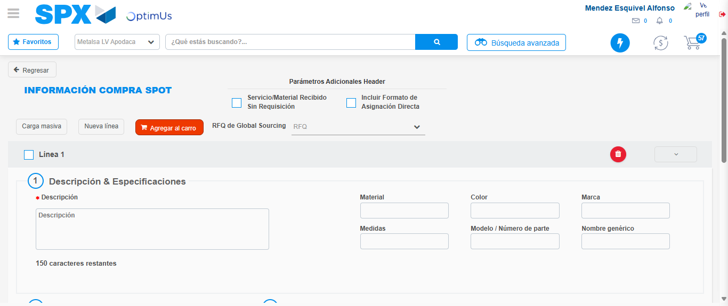Image file-name: QC_Testing-tc002_SPX_Dev5_Crear_Requisicion_Spot_Tipo_Cobro_Project-1784307686581

Step 7 - Return to Main Page SPX : Return to Main Page SPX
Image file-name: QC_Testing-tc002_SPX_Dev5_Crear_Requisicion_Spot_Tipo_Cobro_Project-1784307635779

Image file-name: QC_Testing-tc002_SPX_Dev5_Crear_Requisicion_Spot_Tipo_Cobro_Project-1784307638245

Image file-name: QC_Testing-tc002_SPX_Dev5_Crear_Requisicion_Spot_Tipo_Cobro_Project-1784307667215

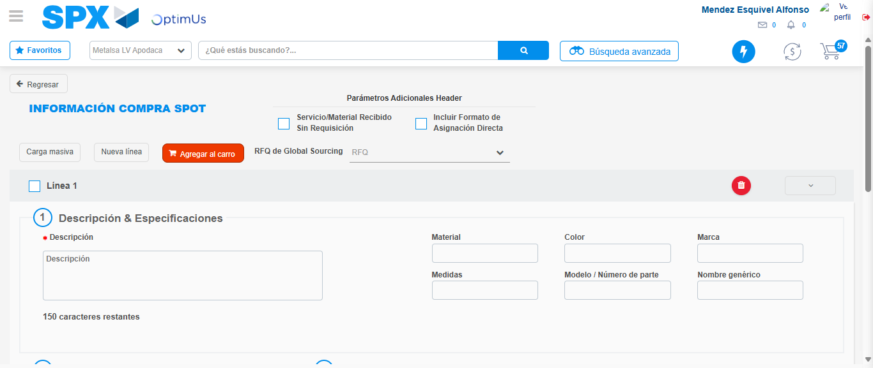Image file-name: QC_Testing-tc002_SPX_Dev5_Crear_Requisicion_Spot_Tipo_Cobro_Project-1784307688776

Image file-name: QC_Testing-tc002_SPX_Dev5_Crear_Requisicion_Spot_Tipo_Cobro_Project-1784307688970

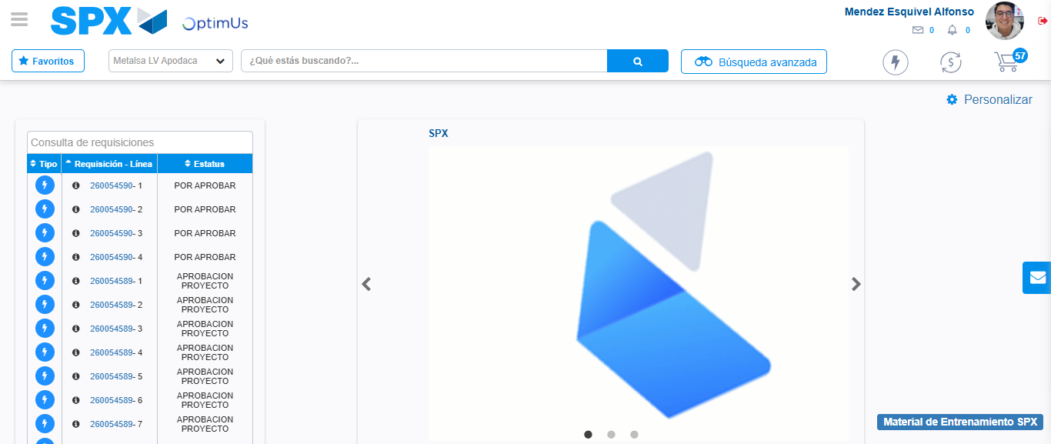Image file-name: QC_Testing-tc002_SPX_Dev5_Crear_Requisicion_Spot_Tipo_Cobro_Project-1784307710137

Step 8 - Log Out : Log Out SPX
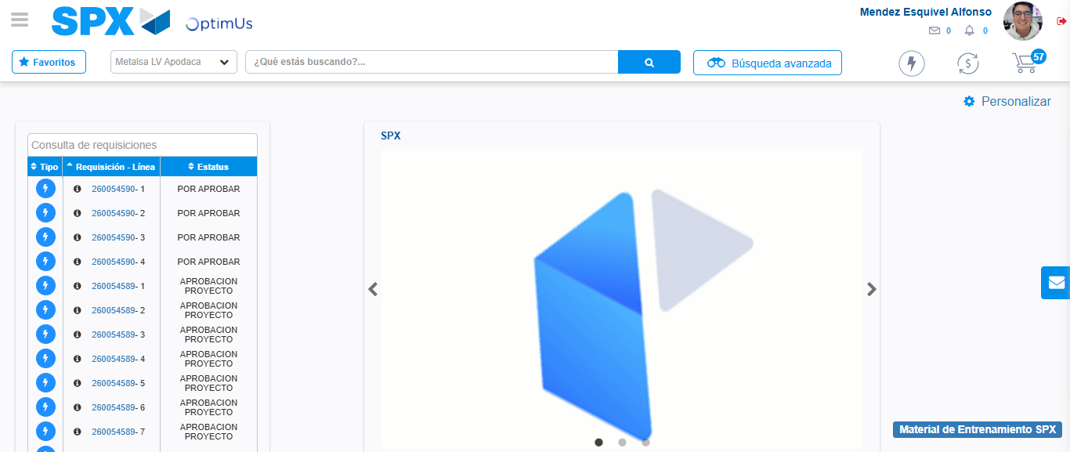Image file-name: QC_Testing-tc002_SPX_Dev5_Crear_Requisicion_Spot_Tipo_Cobro_Project-1784307710374

